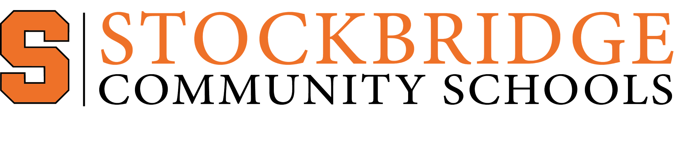

Dena Sommer
Community Education Coordinator
222 Western Avenue, Stockbridge, MI 49285
Phone (517) 710-4129 Email sommerd@panthernet.net
Sponsorship Information
Stockbridge Community Education would like to offer you the opportunity to sponsor one of our youth teams. Local Sponsorship helps provide health recreational activities for young people in the Stockbridge Community School District.

Your sponsorship will help go toward equipment, jerseys, for all players and their coaches. We will also use this money to help purchase new equipment as needed for our sports programs and to purchase an outdoor storage building eventually.

We offer different levels of sponsorship that we have listed below. Please make your check out to Stockbridge Community Education. We can provide you with a tax declaration statement for your business tax purposes as well.

Please select the level of sponsorship you would like to provide and if applicable the name/title you would like on teams shirts. Sorry we can only add names for sponsors, no logos due to space.

Please circle sport and indicate grade level/team you would like to sponsor.
Basketball  What Team: | Baseball / Softball  What team:
Soccer ( Fall or Spring) circle one  What Team: | Volleyball  What Team:

Levels of Sponsorship:
- Bronze Level: $150.00: will give you, Your name on non travel team shirts, if travel team, a sign in school gym or sport field. Social Media Shoutout.

- Silver Level: $250.00: will give you, Your name on non travel team shirts, for travel teams mid size banner in gym/or mid size sign in field, Social Media Shoutout, company name on player warm up shirts and coaches shirt

- Gold Level: $500.00: will give you, Your name on non travel team shirts, for travel teams a large banner in gym/or large sign in field, Social Media Shoutout, company name on player warm up shirts and coaches shirt.

Contact Name:

Phone and Email:
Name to be added to shirts:

